ĐỀ THI TIẾNG ANH Mã đề: 01
Trình độ A2
Họ và tên thí sinh: ……………..……………………………………………………….…………………………………………………………
Số báo danh: ……………..…………………………………………...……. Phòng thi số: …………………………….……………

PAPER TWO LISTENING (Approximately 15 minutes)
PART 1: Questions 1 – 5
There are five questions in this part. For each question there are three answer choices and a short recording. Tick (√) the correct answer. You will hear the piece twice.
Example: How many people were at the meeting?
A. 3 B. 13 √ C. 30

1. What have they forgotten?
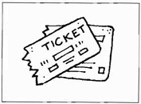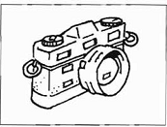
A □ B □ C □
2. What time does the train go?
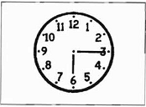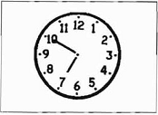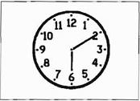
A □ B □ C □
3. What did Raquel buy today?
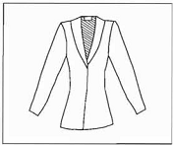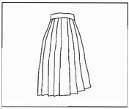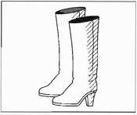
A □ B □ C □
4. How many students are there at the college?

A □ B □ C □
5. How did the woman get to work?
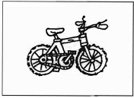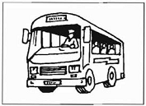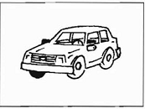
A □ B □ C □

PART 2: Questions 6-10
Listen to Sue talking to a friend about her new clothes. Why did Sue decide to buy each thing?
For questions 6-10, write a letter A-H next to the clothes. You will hear the conversation twice.
EXAMPLE | ANSWER
0 jeans | F
COTHES SUE BOUGHT |  | WHY
6 jacket  7 dress  8 sweater  9 coat  10 T-shirt |  | A big  B cheap  C expensive  D light  E long  F purple  G short  H soft

PART 3: Questions 11-15
Listen to Eric talking to Mary about the weekend. Their friend, Carlos, is coming to visit them.
For questions 11-15, tick (√) A, B, or C. You will hear the conversation twice.
Example: 0. What does Carlos hate?
√ A. shopping
B. museums
C. football

11. When is the football match?
A. Saturday morning
B. Saturday afternoon
C. Sunday afternoon
12. Where are they going to eat on Saturday evening?
A. at home
B. in an Italian restaurant
C. in a Chinese restaurant
13. What are they going to do on Sunday morning?
A. go for a drive
B. get up late
C. go to the cinema
14. Where are they going to have lunch on Sunday?
A. in a cafe
B. in a pub
C. at home
15. They can’t go to the cinema on Sunday afternoon because
A. Carlos doesn’t like films
B. Eric doesn’t like films
C. they don’t have time

